* [Create a new Key Pair](https://catalog.workshops.aws/general-immersionday/en-US/basic-modules/10-ec2/ec2-linux/1-ec2)

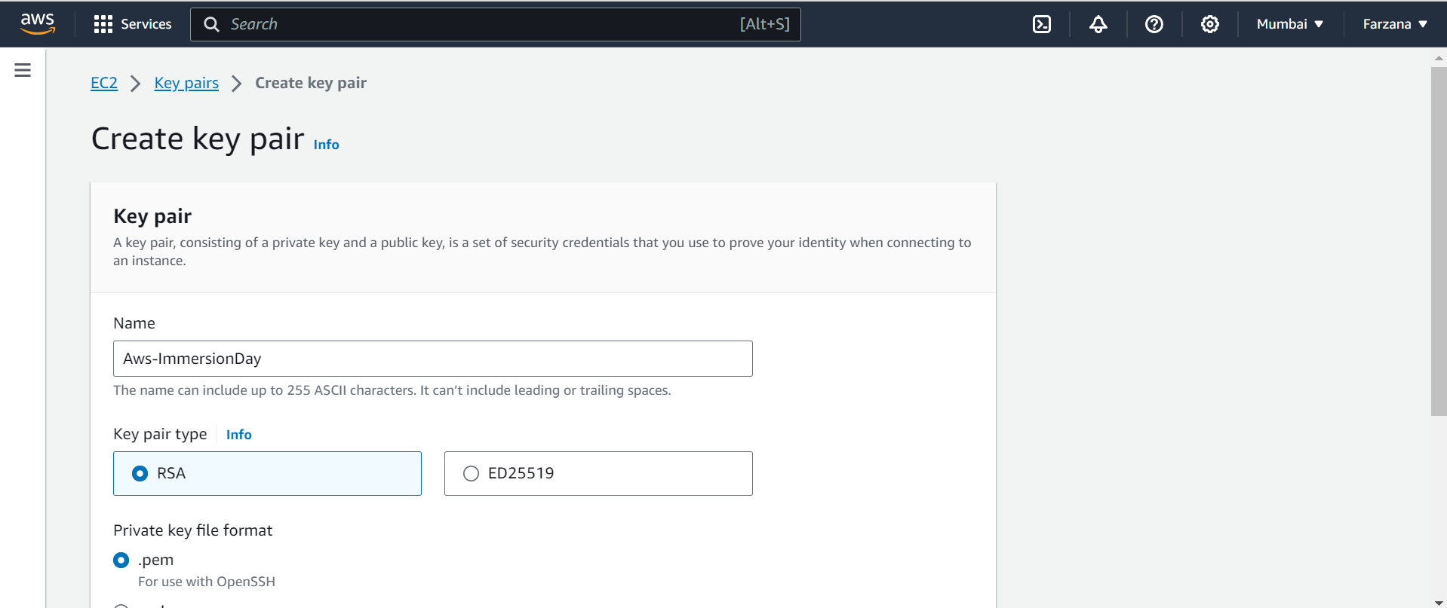

* [Launch a Web Server Instance](https://catalog.workshops.aws/general-immersionday/en-US/basic-modules/10-ec2/ec2-linux/2-ec2)

